European landscapes [♪]

- THE MEDITERRANEAN CLIMATE.

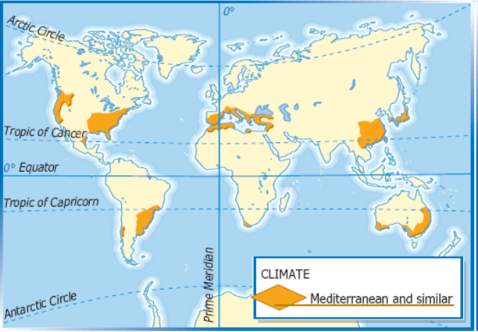

We can find a Mediterranean climate on the east and on the west coast of the USA, on the east coast of Mexico, on the coast of Argentina, Uruguay and Brazil, in the south of Portugal, Spain and France, in Italy, in the Balkan Peninsula, in the north of Morocco, Algeria and Libya, on the coast of Turkey, Syria, Lebanon and Israel, in the south of Swaziland and south Africa, in the south-west of China, in Japan and in the south of Australia.

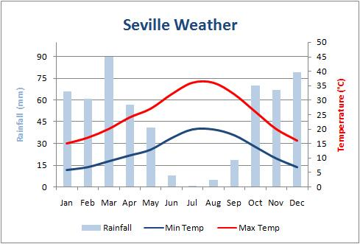 | The lowest average temperature during the year is 6 °C. The highest is 36 °C. It isn’t so rainy in July. It is rainy in March.  Temperatures are low in winter and hot in summer.  The hottest months are July and August and the coldest month is January.  There are big differences between the seasons.  The annual total rainfall is 560 mm. It isn’t abundant, and it isn’t distributed over the year because it isn’t rainy in the summer.

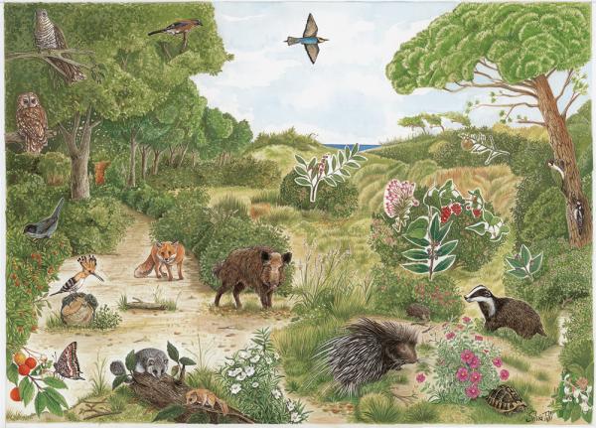

The animals of Mediterranean landscapes are the badger, the woodpecker, the tortoise, the hedgehog, the boar, the fox, the hoopoe, the squirrel, the butterfly and the owl.
There are pines and bush.
- THE ALPINE CLIMATE

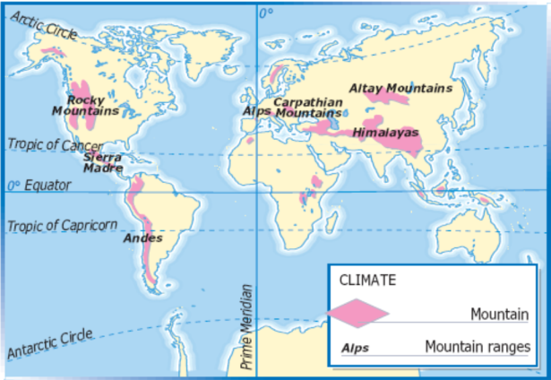

We can find an alpine climate in the Rocky Mountains, the Sierra Madre (on the Tropic of Cancer), the Andes (crossed by the Tropic of Capricorn), the Alps, the Carpathian Mountains, the Altay Mountains and in the Himalayas (north of the Tropic of Cancer).

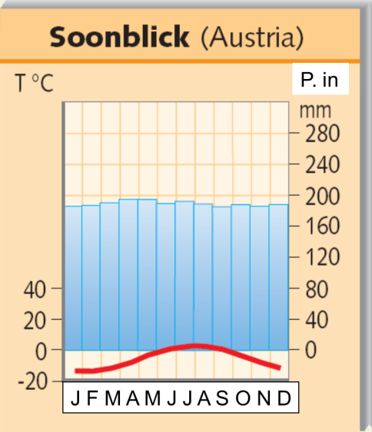 | The lowest average temperature during the year is -18 °C, the highest is + 5°C. It rains all over the year.  Temperatures are very low in winter and low in summer. January is the coldest month, but there aren’t big differences between the seasons.  The annual total rainfall is abundant; it is about 2,500 mm and it is distributed all over the year.

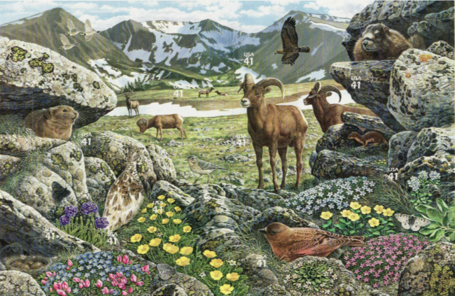

In alpine areas there are butterflies, marmots, beech-martens, eagles, chamois, etc.

- THE CONTINENTAL CLIMATE

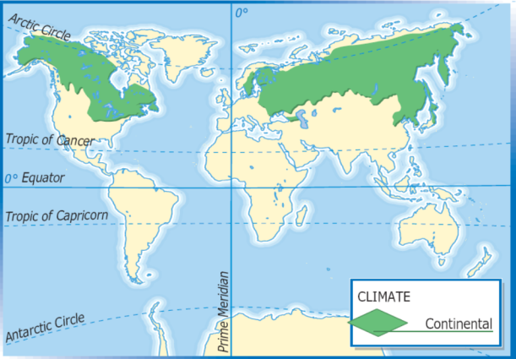

The continental climate is in North America (Canada, Alaska) and in northern Asia (Siberia, Finland and Sweden).

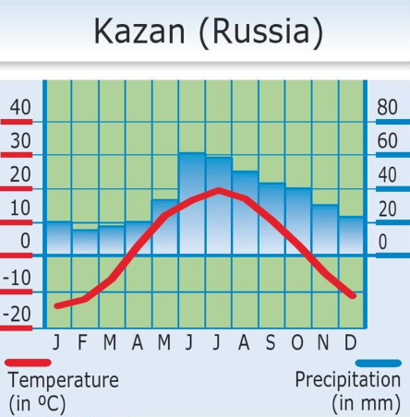 | The lowest average temperature during the year is -13°C, the highest is +20°C. It isn’t so rainy in February, it is rainy in June.  Temperatures are very low in winter and hot in summer. July is the hottest and January is the coldest month of the year, there are big differences between the seasons.  The annual total rainfall is about 240 mm. It isn’t abundant and it rains mostly in summer.

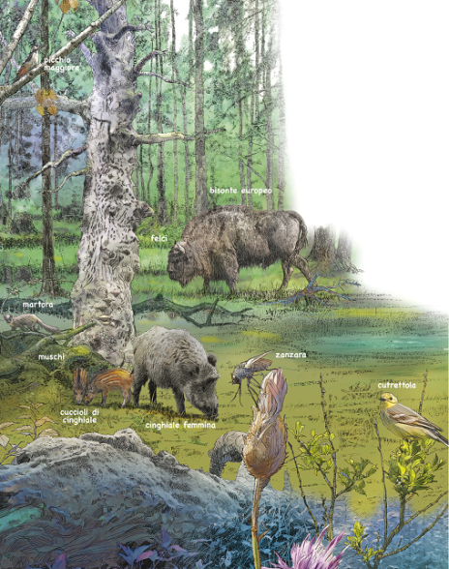

Boars, beavers, bluebirds, buffaloes, mosquitoes and woodpeckers are typical animals of continental climates; pines and oaks are typical plants.
- THE OCEANIC CLIMATE.

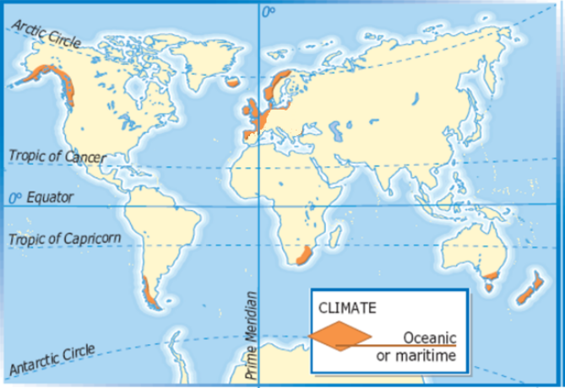

We can find an oceanic climate in European countries like Norway, England, Ireland, and on the coast of Spain and France.
We also find an oceanic climate in America, on the coast of Alaska, Canada and Chile, and in South Africa.
There is an oceanic climate in Oceania, on the south-eastern coast of Australia and in New Zealand.

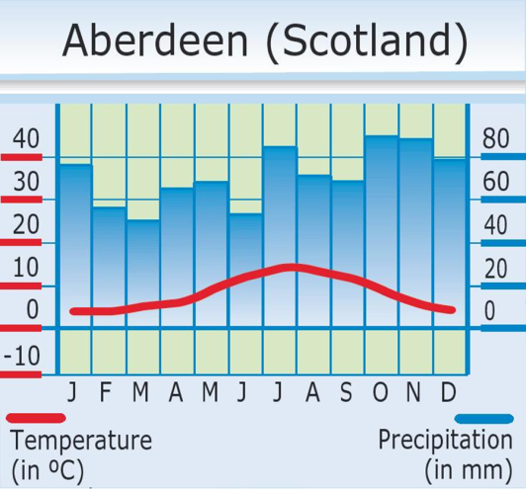 | The lowest average temperature during the year is 4°C/5°C, The highest is 16°C/17°C. It isn’t so rainy in March, it is rainy in October.  Temperatures are low in winter and cool in summer.  The hottest month is July and the coldest are January and February.  There aren’t big difference between the seasons.  The annual total rainfall is about 850 mm. It is abundant and it rains all over the year.

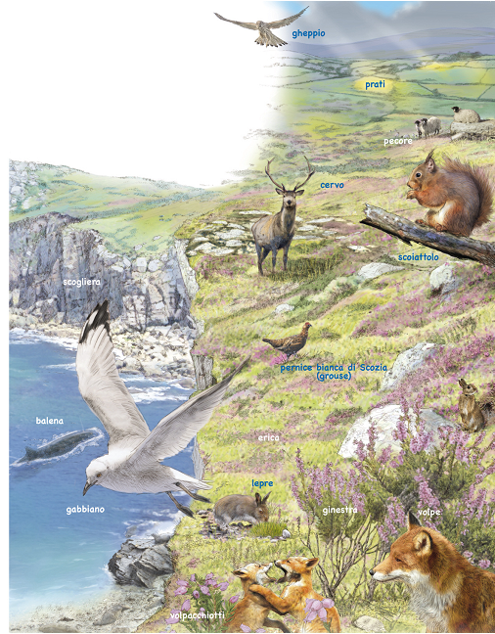

In the moorland of oceanic landscapes you can find the fox, the squirrel, the deer, the seagull, the hawk, the whale and the hare. There is low vegetation.

- THE POLAR CLIMATE.
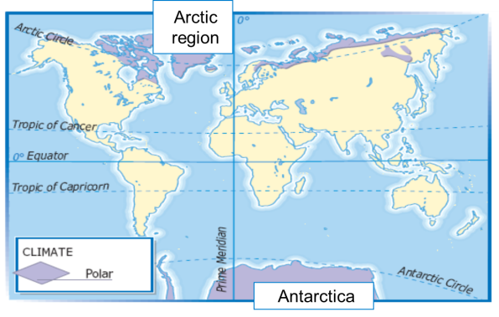

We can find a polar climate in the Arctic region and Antarctica, in Canada, in Greenland and in northern Russia.

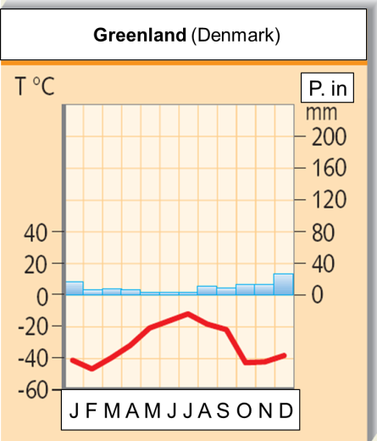 | The lowest average temperature during the year is -45°/-50°C. The highest is  -15°/-10 °C. It isn’t so rainy in May, June and July. It is rainy in January and December.  Temperatures are extremely low in winter and very low in summer. February is the coldest month of the year. There are big differences between the seasons.  The annual total rainfall is about 160-180 mm, it isn’t abundant and it rains a little all over the year.

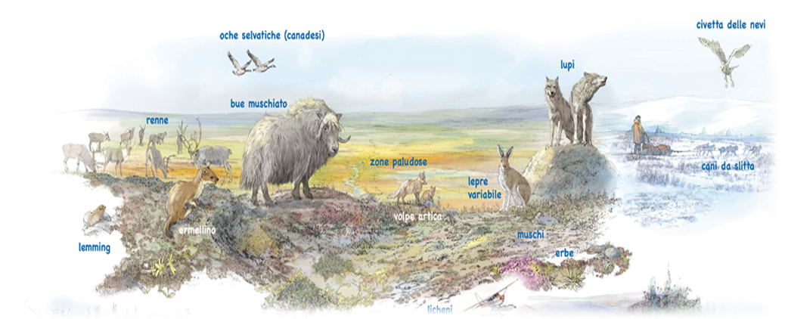

The animals of polar landscapes are the reindeer, the wild goose, the lemming, the stoat, the muskox, the arctic fox, the hare, the wolf, the snow owl and the sled dog.
There is swamp, lichens and herbs.

